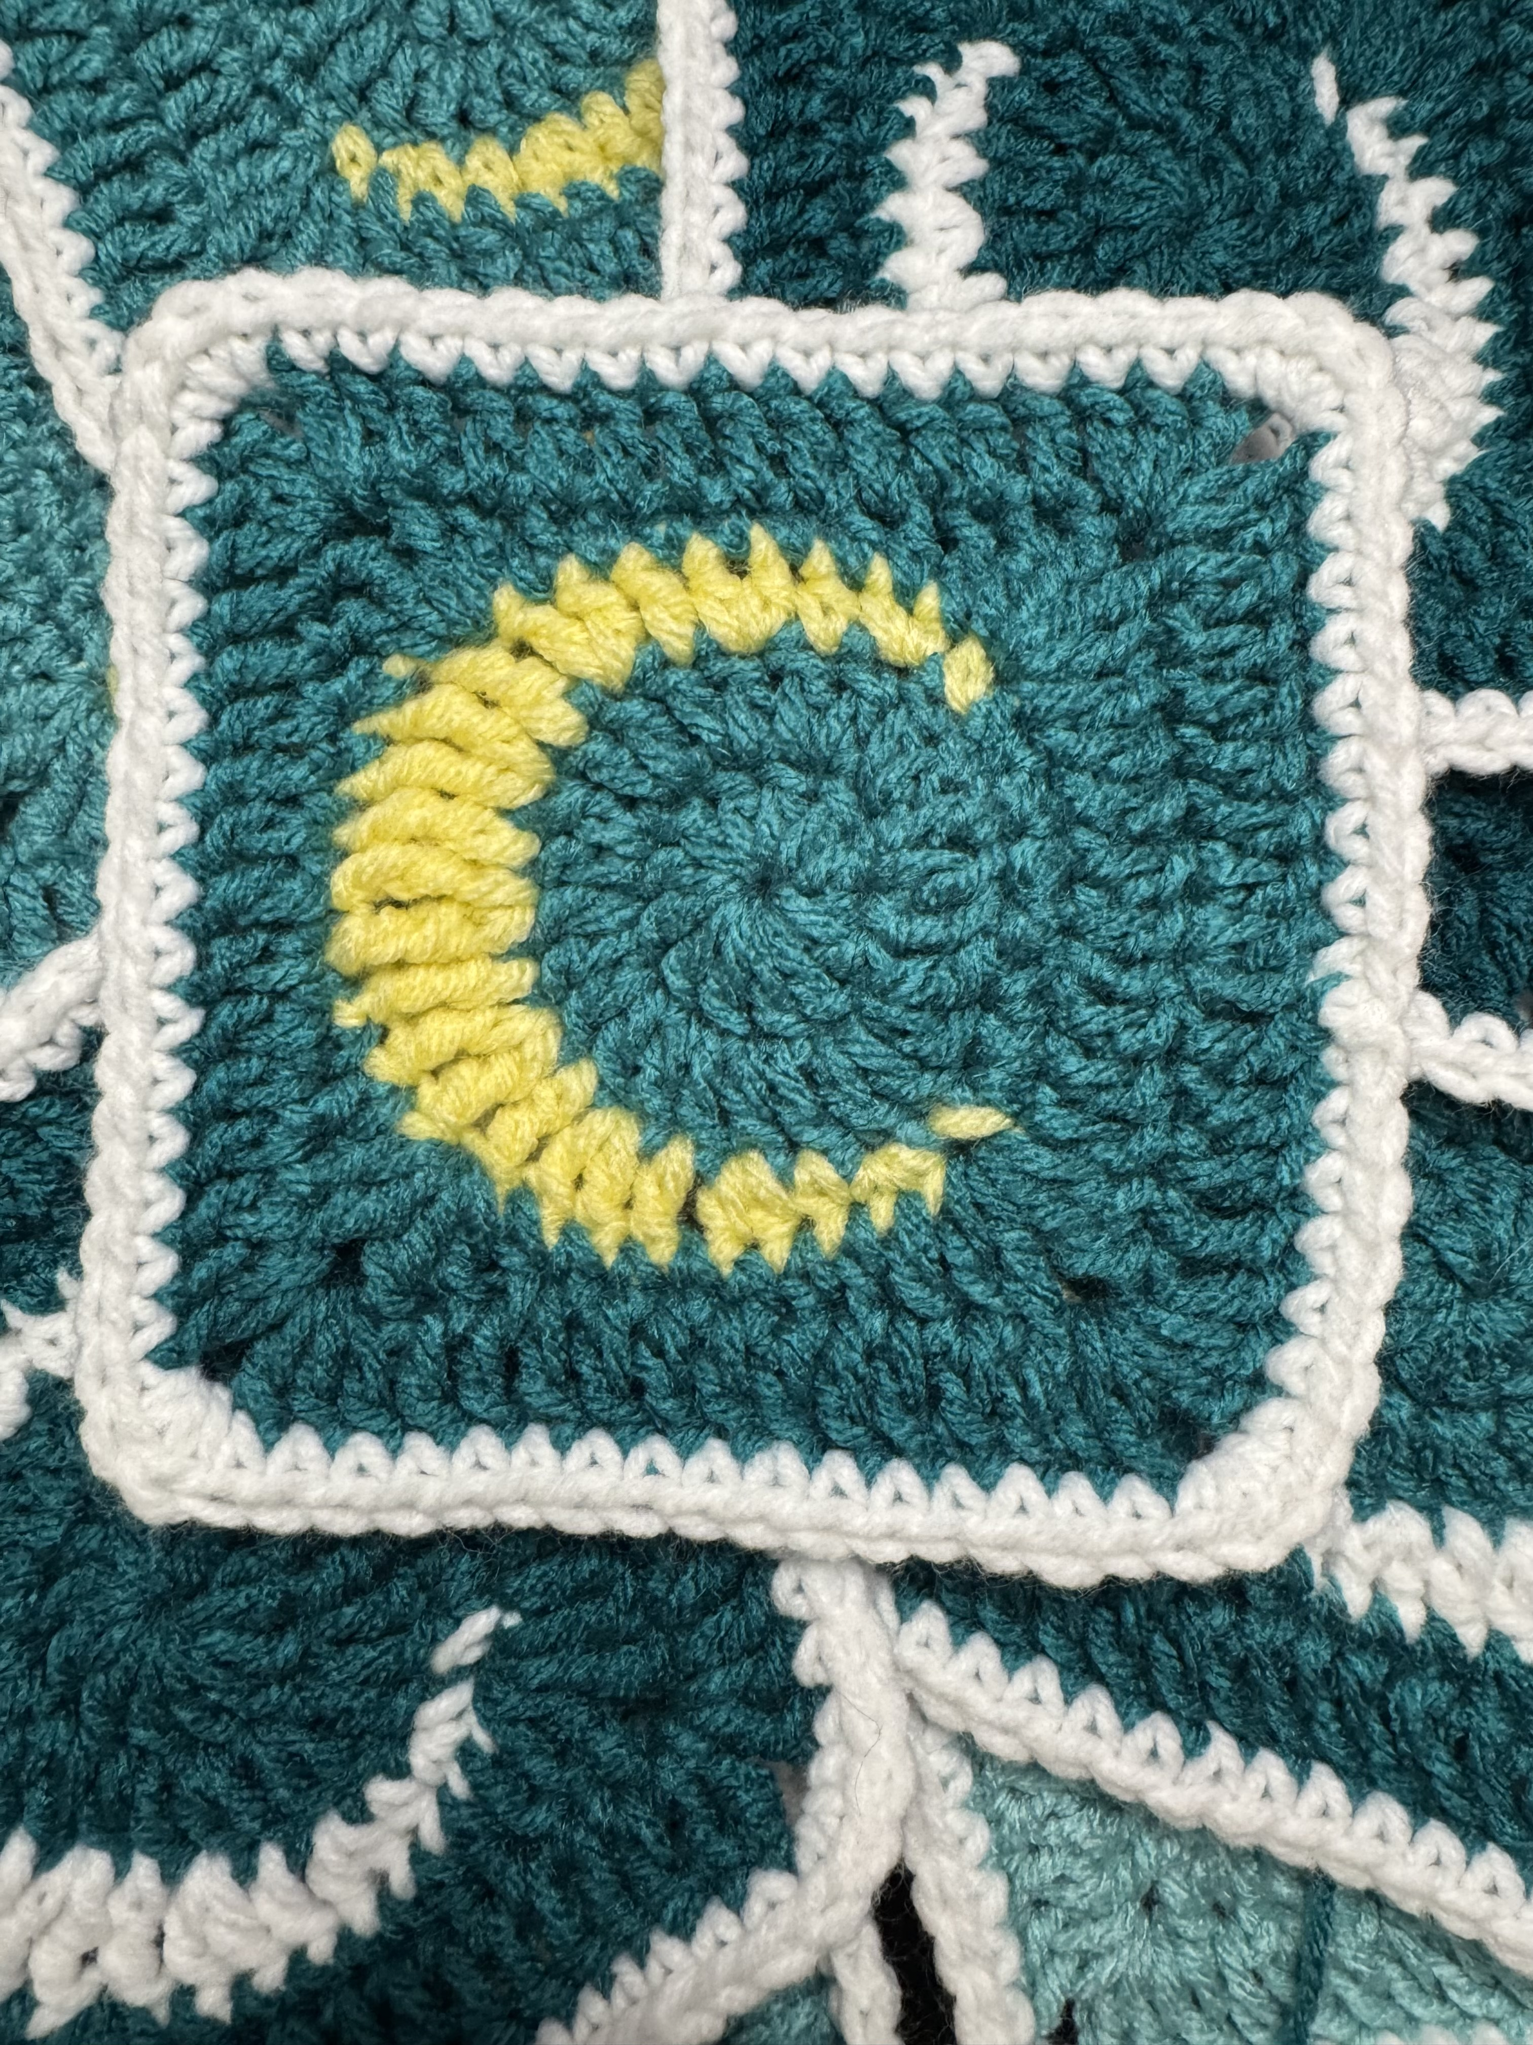


Moon Square
By EndlessKnots Crochet
I used 3 different colors in this pattern, but the color is your choice! The color of the square will be referred to as color A. The moon color will be color B and the border will be color C! Use any size yarn with the corresponding hook size!
Round 1: With color A. Ch3. In the 3rd ch from hook, work 12dc. Sl St to first dc. {12}
Round 2: Ch 2. inc around. Sl st to first dc. {24}
Round 3: Ch 1. Sc, inc, sc. Change to color B (leave color A attached). Now we will be creating the moon. Sc, sc inc, hdc, hdc inc, dc, dc inc, tr, tr inc, tr, extended-tr inc, tr, tr inc, tr, dc inc, dc, hdc inc, hdc, sc inc, sc (change back to color A, fastening off color B) sc inc, sc. Sl st to first sc. {35}
Round 4: Ch 2. 5dc, [dc,tr,ch1,tr,dc], this is the first corner. Dc, 2hdc, 4sc, hdc, [dc,tr,ch1,tr,dc], hdc, sc, 4sl st, sc, hdc [dc,tr,ch1,tr,dc], hdc, 4sc, 2hdc, dc [dc,tr,ch1,tr,dc] 3dc, sl st to first dc.
Round 5: Ch 2. 7dc, [2dc,ch2,2dc] in ch sp, * 12dc, [2dc,ch2,2dc]in ch sp, * repeat from * to * 3x, 5dc, sl st to first dc. Change to color C. {64}
Round 6: Ch 1. 9sc, 3sc in ch sp, [16sc,3sc in ch sp]3x, 7sc. F.O

EndlessknotsCrochet.com

